**CO543: Image Processing**

**Lab 5**

Ranage R.D.P.R. - E/19/310

**1. Read the image texture.tif. Display the image. How many textures are there in the image? Describe them.**

#importing libraries

import cv2

import numpy as np

import matplotlib.pyplot as plt

img = cv2.imread('texture.tif', 0)

plt.imshow(img, cmap='gray')

plt.show()

There are 5 different textures and two are plain colors.

* Plain Color 1: The cluster with uniform grayscale intensity corresponding to a solid color.(Bottom Left)
* Plain Color 2: The other cluster with a different uniform grayscale intensity.(Bottom Right)
* Texture 3: The cluster with consistent patterns and minor variations in grayscale.(Top Left)
* Texture 4: The cluster with a more complex pattern and significant grayscale variation.(Top Right)
* Texture 5: The cluster with a unique and distinct pattern.(Middle)

**2. Select several features and calculate them on blocks of size of 12 × 12 using Gabor filter. Display the calculated features and estimate which ones can be used to segment given structure.**

**For the selected images apply the K-means method and comment on the results.**

#defining parameters

ksize = 8

sigma = 5

theta = 1*np.pi/4

lamda = 1*np.pi/4

gamma=0.9

phi = 0.8

#creating the kernal

kernel = cv2.getGaborKernel((ksize, ksize), sigma, theta, lamda, gamma, phi, ktype=cv2.CV_32F)

#creating the image using the kernal

filter_img = cv2.filter2D(img, cv2.CV_8UC3, kernel)

kernel_resized = cv2.resize(kernel, (400, 400))

#plotting images

plt.figure(figsize=(12, 5))

plt.subplot(1,3,1), plt.imshow(img, cmap='gray')

plt.title('Original Image')

plt.subplot(1,3,2), plt.imshow(filter_img, cmap='gray')

plt.title('Filtered Image')

plt.subplot(1,3,3), plt.imshow(kernel_resized, cmap='gray')

plt.title('Kernel Visualization')

plt.show()

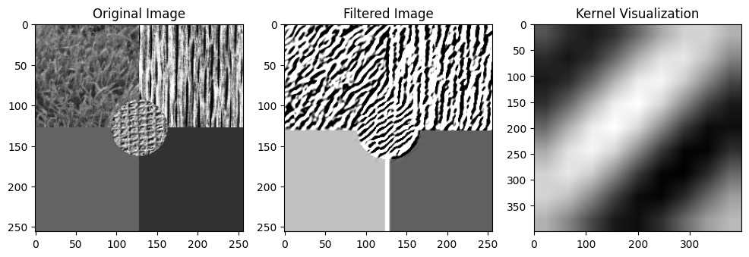

image_data = filter_img.reshape(-1, 1).astype(np.float32)

kmeans_criteria = (cv2.TERM_CRITERIA_EPS + cv2.TERM_CRITERIA_MAX_ITER, 100, 0.2)

_, kmeans_labels, kmeans_centers = cv2.kmeans(image_data, 2, None, kmeans_criteria, 10, cv2.KMEANS_RANDOM_CENTERS)

kmeans_centers = np.uint8(kmeans_centers)

segmented_result = kmeans_centers[kmeans_labels.flatten()]

segmented_result = segmented_result.reshape(filter_img.shape)

plt.imshow(segmented_result, cmap='gray')

plt.title('Segmented Image using K-means')

plt.xticks([]), plt.yticks([])

plt.show()

**3. Calculate the spectra energy (without the DC component) feature on the texture.tif image, on the blocks of size 12×12. Is this feature good for segmentation of the textures on this image? Segment the energy image using the K-means method and comment on the results.**

def spectral_energy(image, block_size):

    energy = np.zeros_like(image)

    for i in range(0, image.shape[0], block_size):

        for j in range(0, image.shape[1], block_size):

            block = image[i:i+block_size, j:j+block_size]

            f = np.fft.fft2(block)

            fshift = np.fft.fftshift(f)

            magnitude_spectrum = 20 * np.log(np.abs(fshift) + 1e-10)

            energy[i:i+block_size, j:j+block_size] = np.sum(magnitude_spectrum)

    return energy

energy_image = spectral_energy(img, 12)

reshaped_image = np.float32(energy_image.reshape(-1, 1))

criteria = (cv2.TERM_CRITERIA_EPS + cv2.TERM_CRITERIA_MAX_ITER, 100, 0.2)

_, labels, centers = cv2.kmeans(reshaped_image, 2, None, criteria, 10, cv2.KMEANS_RANDOM_CENTERS)

segmented_image = centers[labels.flatten()].reshape((energy_image.shape))

plt.figure(figsize=(10, 5))

plt.subplot(1,2,1), plt.imshow(energy_image, cmap='gray')

plt.title('Spectral Energy')

plt.subplot(1,2,2), plt.imshow(segmented_image, cmap='gray')

plt.title('Segmented Energy using K-means')

The segmentation based on spectral energy appears to separate regions of high and low texture. Visually, it's effective, but sensitivity to noise and parameter settings might affect accuracy. Post-processing and trying alternative algorithms could improve results.

**4. By using segmentation and cv2.inpaint restore the “Efac.jpg” image. In your report explain the steps you used to achieve it.**

import cv2

import numpy as np

import matplotlib.pyplot as plt

img = cv2.imread('Efac.jpg')

hsv_img = cv2.cvtColor(img, cv2.COLOR_BGR2HSV)

pink_lower = np.array([140, 50, 50])

pink_upper = np.array([180, 255, 255])

cyan_lower = np.array([80, 50, 50])

cyan_upper = np.array([100, 255, 255])

mask_pink = cv2.inRange(hsv_img, pink_lower, pink_upper)

mask_cyan = cv2.inRange(hsv_img, cyan_lower, cyan_upper)

combined_mask = cv2.bitwise_or(mask_pink, mask_cyan)

restored_img = cv2.inpaint(img, combined_mask, 3, cv2.INPAINT_NS)

restored_img_path = "Efac_restored.jpg"

cv2.imwrite(restored_img_path, restored_img)

img = cv2.cvtColor(img, cv2.COLOR_BGR2RGB)

restored_img = cv2.cvtColor(restored_img, cv2.COLOR_BGR2RGB)

plt.figure(figsize=(15,5))

plt.subplot(1,3,1), plt.imshow(img, cmap='gray')

plt.title('Original Image')

plt.axis('off')

plt.subplot(1,3,2), plt.imshow(combined_mask, cmap='gray')

plt.title('Combined Mask')

plt.axis('off')

plt.subplot(1,3,3), plt.imshow(restored_img, cmap='gray')

plt.title('Restored Image')

plt.axis('off')

plt.show()

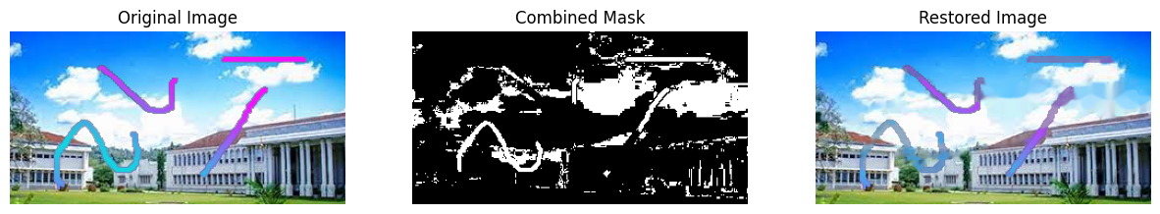

**STEPS**

**Color-based Masking:** Convert the image to HSV color space and define color ranges for damaged areas (pink and cyan). Create binary masks for each damaged area using cv2.inRange().

**Combining Masks:** Combine the individual masks for pink and cyan damaged areas using bitwise OR operation (cv2.bitwise_or()) to create a single mask representing all damaged areas.

**Inpainting:** Apply the combined mask to the damaged image using cv2.inpaint() with the Navier-Stokes-based method (cv2.INPAINT_NS) to restore the damaged areas seamlessly.